The Scottish Countryman | Inspired Falconry

Accessibility Statement

Table of Contents
Introduction 3
Pre-arrival 3
Arrival 4
Contact Information 4
Local Accessible Taxi: 5
Stagecoach Bus Times and Access information: 5

Introduction
- The Scottish Countryman | Inspired Falconry is located on a single carriageway rural road, the A917.
- It is 8 miles from St Andrews and 1 mile from the village of Crail.
- There are no pavements on our section of the A917 but the roads are generally quiet and often frequented by cyclists and walkers.
- A driveway entrance with signage and bunting welcomes you to The Scottish Countryman | Inspired Falconry.
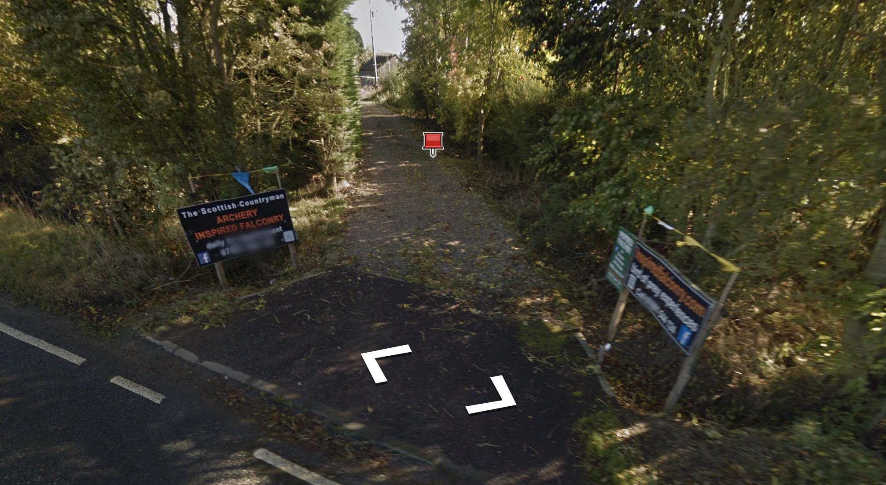
- The car parking and drive are hard-standing with a gravel infill system making it passable for wheelchair users. There is a drop off area next to the mews area and archery field with several accessible parking spaces.

Pre-arrival
- The easiest way to arrive is by car.
- The closest bus station is in St Andrews (8 miles away).
- There is an hourly bus service (the St Andrews – Leven service, number 95) with a designated stop outside The Scottish Countryman | Inspired Falconry, called Hammer Inn.
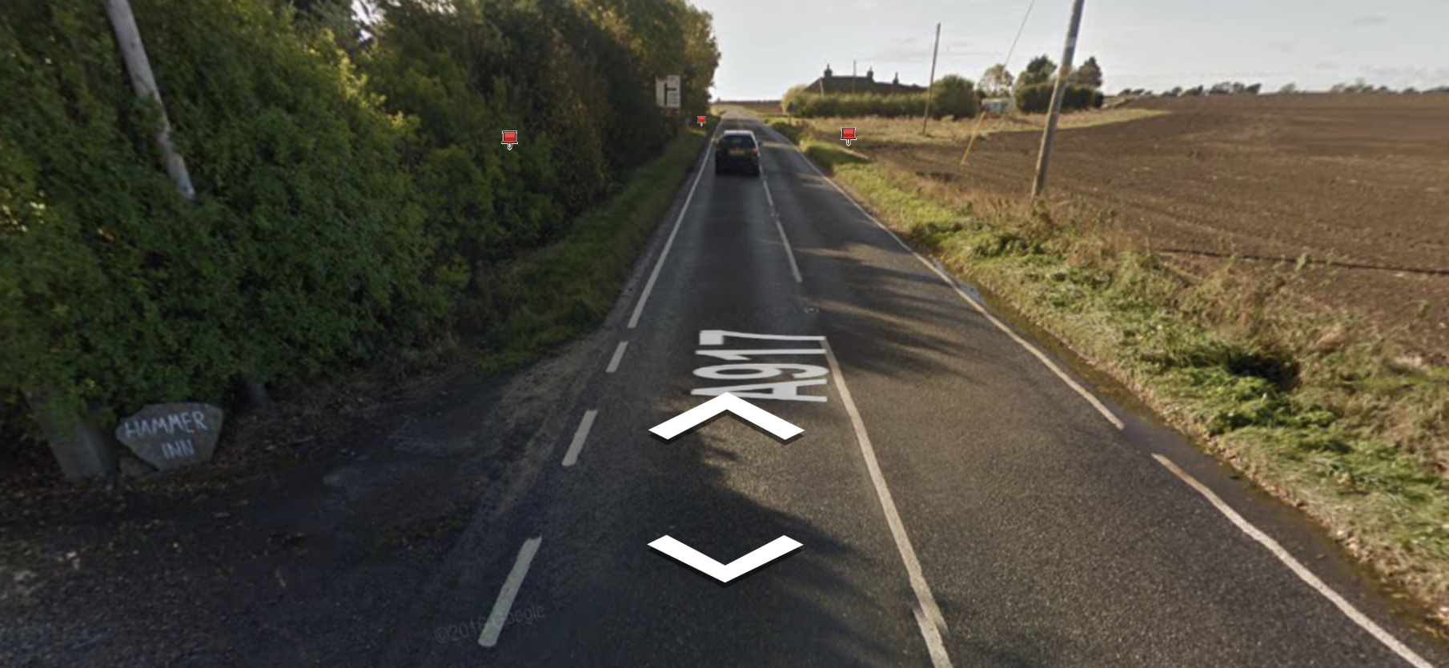
- An accessible taxi service is available by contacting Taxi Centre Fife, who provide various sizes of vehicles for longer distances such as airport pick-ups. (Tel: 01333 300 300 http://www.taxicentrefife.com/)
- We can also offer a collection service from St Andrews or the East Neuk.

Arrival

On arrival, you will be met by Steven Brazendale. Steve can assist with parking and accessing the mews area or archery field and will be able to provide you with an introduction and safety briefing, as required.

Contact Information
- Contact Name: Steven Brazendale
- Address (including postcode): The Scottish Countryman | Inspired Falconry, Hammer Inn, by Crail, Anstruther, Fife KY10 3XQ
- Telephone: 07801 544 124
- Email: hello@thescottishcountryman.co.uk
- Website: www.thescottishcountryman.co.uk
- Grid Reference finder link: https://gridreferencefinder.com/?gr=NO6058409200|Point_s_E|0&t=Point%20E&v=h
- Grid Reference: NO 60584 09200
- Latitude: 56.273629 Longitude: -2.6380730
- Hours of Operation: in summertime from 10:30am to 7:30pm; at other times of year, by arrangement

Local Accessible Taxi:
- Town and Country Taxis 01334 840 444 (pre-book only)
- Go-Flexi taxibuses cover large areas of rural North and East Fife. Phone to book a journey and your fare will be similar to a bus fare. http://bit.ly/2hQ4JSO

Stagecoach Bus Times and Access information:
St Andrews to Leven: https://www.stagecoachbus.com/routes/east-scotland/95/st-andrews-leven/xhco095.i
Leven to St Andrews: https://www.stagecoachbus.com/routes/east-scotland/95/leven-st-andrews/xhco095.o

